A Project Work On Social Studies

**Skyrider Secondary English Boarding School**

**Ratnanagar-12,Chitwan**

**056-61174**

**056-562782**

**6/2/2075**

The Problems of Agriculture in Nepal.

Group Members: 1. Prithak Adhikari 2. Aadarsha Regmi 3. Mandip Adhikari 4. Anamol Chapagain 5. Aayan Malla 6. Roshan Poudel 7. Prabin Guni 8. Sonim Rimal

***Introduction***

A **farmer** (also called an **agriculturer**) is a person engaged in [agriculture](https://en.wikipedia.org/wiki/Agriculture), raising living organisms for food or raw materials. The term usually applies to people who do some combination of raising field [crops](https://en.wikipedia.org/wiki/Crops), [orchards](https://en.wikipedia.org/wiki/Orchard), [vineyards](https://en.wikipedia.org/wiki/Vineyard), [poultry](https://en.wikipedia.org/wiki/Poultry), or other [livestock](https://en.wikipedia.org/wiki/Livestock). A farmer might own the farmed land or might work as a laborer on land owned by others, but in advanced economies, a farmer is usually a [farm](https://en.wikipedia.org/wiki/Farm) owner, while employees of the farm are known as farm workers, or farmhands. However, in the not so distant past, a farmer was a person who promotes or improves the growth of (a plant, crop, etc.) by labor and attention, land or crops or raises animals (as livestock or fish).

`***Objectives of the research***

1. To find out the problems faced by the farmer.
2. To find the profit gained by the farmer.

***Methods of the research***

We were able to apply primary source for this research. We visited house of some farmers in our locality. We interviewed some of the farmers in our community and asked some questions making questionnaire.

We also applied some of the methods of secondary sources using books, internet etc. and took some information from it too.

***Findings***

After the research with the farmers, we found that the people of our community were commonly using Traditional method of Farming. The farmers are using organic fertilizers and not using tractors to plough the field because they don’t have a budget. That means, they don’t have great income.

There are many problems that we found during the interview with those farmers. They are listed below:

**1. Small and fragmented land-holdings**  
**2. Seeds**  
**3. Manures, Fertilizers and Biocides**  
**4. Irrigation**  
**5. Lack of mechanization**  
**6. Soil erosion**  
**7. Agricultural Marketing**  
**8.** **Scarcity of capital**

We asked the farmers that what they expect the government to do for the betterment of their occupation. And we got these answers:

* Insurance as part of agriculture policy
* Provision of Fertilizers to the farmers
* Provision of Easy Loan Facilities
* Providing Modern Machineries and Technologies

***Conclusion***

In a nutshell, we know that the condition of farming in the context of Nepal is really off. Farmers are compelled to use ancient technology of farming. People have many complaints about the current conditions of Nepal. The government should give many more facilities. By saying this, our group would like to end this report by saying that there are many problems to be solved in many more circumstances than everyone else than farmers thinks.

***Data of a Farmer***

* Name of the farmer: Arman Alam
* Phone Number: 9865042099
* 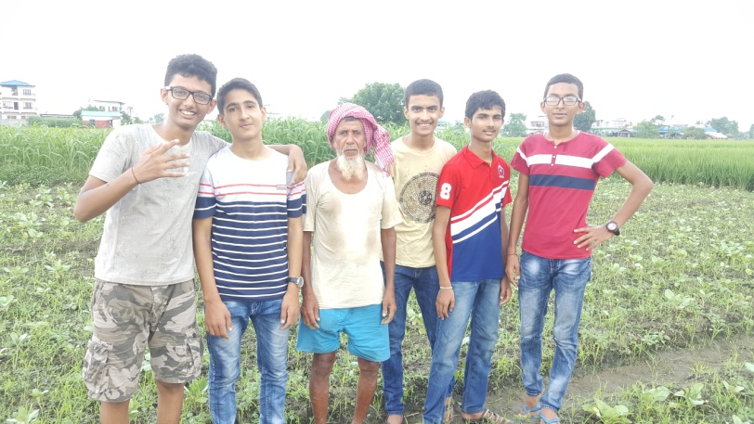Locality: Bairiya
* Type of Farming: Vegetable Farming
* Area Of Land: 24 kattha
* Wage of Land: Rs. 7000 monthly
* No. of Labour: Family plus other 9 labours.
* Maximum/Minimum Production: 27 quintal/ 10 quintal
* Total Income: 50,000 Montly
* Problems: Traditional tools, irrigation problems.
* Reform from government: Easy Loans, Modern Tools and Technologies

***Data of a Farmer***

* Name of the Farmer: Kiridash Khan
* Phone Number: ----------
* Locality: Debauli
* Type of Farming: Vegetable Farming
* Area of Land: 2 bigga
* Wage of Land: Rs. 16,000 monthly
* No. Of Labor: Family plus other 10 people
* Maximum/ Minimum Production: 40-50 quintal/ 25 quintals
* Total Income: Rs. 75,000 monthly
* Problems: Lack of Proper Market, Lack of Improved Seeds, Lack of Transportation Facilities etc.
* Reform from Government: Producing Quality Product, Provision of Soft Loan and Sub-sidies, Provision of modern technologies etc.

***Data of a Farmer***

* Name of the Farmer: Susila Chaudhary
* 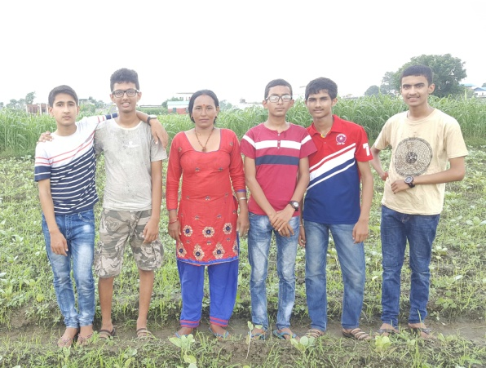Phone Number: -----
* Locality: Bhaktini Bangaicha
* Types of Farming: Vegetable Farming
* Area of Land: 16 kattha
* Wages of Land: Owner
* No. of Labors: 12 people
* Maximum/ Minimum Production: 14 Quintal/ 7 Quintal
* Total Income: Rs. 20,000 monthly
* Problems: Lack of Raw Materials, Problem of Market etc.
* Reform from the Government: Provision of Improved Seeds, Chemical Fertilizers, Easy Loan Facilities